Hello everyone,

Already we are one week into the new school year and we are off to a flying start. There has been some fantastic learning going on as I dropped in to visit everyone. I know that all the staff and students have had a fantastic first week.

New Members at TBS.
Over the coming weeks the new teachers will introduce themselves to you. We start this week with Mr Higgins and Mrs Bright.

Meet our Deputy Head Teacher!
All About Me
Hello everybody,
My name is Chris Higgins and I am the new Deputy Head Teacher here at Two Boats School. I have been a primary school teacher and leader for the past 6 years and am passionate about ensuring that all children reach their fullest potential. I am really excited for the years ahead on Ascension and am really looking forward to working alongside Mrs Maggott in implementing her vision for the school. I will be undertaking the position of the Year 5/6 teacher until we recruit the right candidate into the role. At this point, I will teach a number of classes across the primary and secondary school and will also support Mrs Maggott in leading the school. I have had the pleasure of meeting some of you already and look forward to speaking to those of you who I haven’t yet met – If you see me around school, or the island, please do say hello. My Partner (Ant) and I have settled into life on the island and have been warmly welcomed by everybody we have met… Although I definitely didn’t sign up for all of this rain!!!
See you all soon,
Mr Higgins
Meet our Assistant Head Teacher!
All About Me
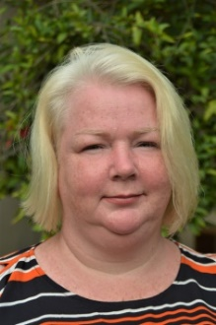
Hello – My name is Wendy Bright and I am the Assistant Head Teacher in charge of Secondary School and maths teacher. I have worked in teaching for 21 years and am passionate about supporting children’s mental health and wellbeing as well as their academic attainment. I am looking forward to meeting all the children and their families from the school in my new role. The school is so welcoming and everyone has high aspirations to do their very best. There are some very exciting lessons planned and I am looking forward to seeing these delivered I have lived in up and down the UK, our last settlement being Shropshire after having been posted there with my husband’s RAF/Army career. I have a son, now aged 24 who has a child of his own (my grandson Zachery) and 2 daughters, aged 18 and 8, Ada is here with us enjoying Ascension life! We love how warm and welcoming the local community are and enjoy exploring beautiful countryside and ocean.
A few of my Favourites things-
Food: Chinese Sport: Hmmmmmm…..I have run the London marathon twice!
Movies: 5th Element Subjects: Engineering and Mathematics
Colour: midnight blue Books: A Faraway Tree Series by Enid Blyton
Place: Near water Animal: Dog

We welcomed to school the following new students:
George Giles, Ngozi Ndubuisi, Bailee Benjamin (Yr 1).
Ada Bright (Yr 4)
Leeanna Johnson (Yr 8)
Joining us on Monday will be Isabella and Georgia Meth (Yr 6 & Yr 11).

On Thursday our new Nursery cohort also started school. See the piece from Mrs Roberts on a separate page.

Thank you and goodbye to Mr Mervyn who has finished with us here at the school. Mervyn stepped up to help us out and did many jobs whilst he was here with us. Enjoy your retirement now Mr Merv.
Please be aware also that Mrs Denise John is away on overseas leave. Mrs Natasha Timm will be covering for Denise during her absence. She can be contacted by phone or on Denise’s email.
On Medical leave still is Mrs Winnie Bagley and Mrs Celia Reynolds our TA’s.

J4G Day.
Today we celebrated Jeans for Genes day. Staff and students all pulled on their favourite denim and made a donation for the charity. At lunchtime some of the teachers took their place in the stocks and were sponged to boost our collection. If you took up the opportunity to join us in support of jeans for genes day, thank you to you all, please send all donations our way for forwarding on to the charity. Remember if you would like to send us a photo we will include it is our next edition. Thank you to the Mitie Fire fighters for your kind donation.

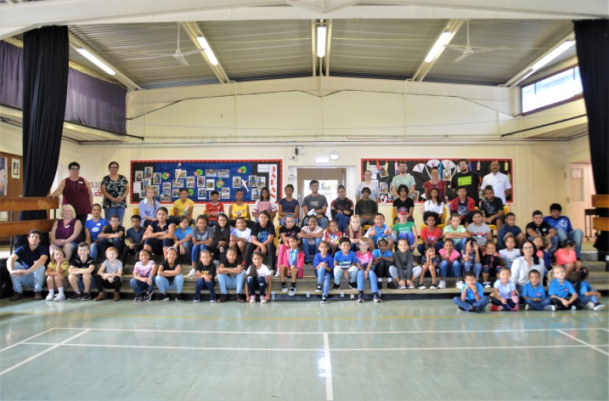
(Two Boats School Group Photo)
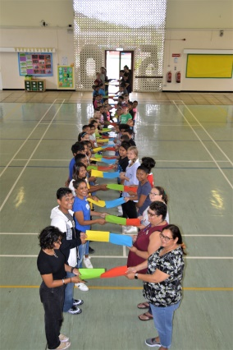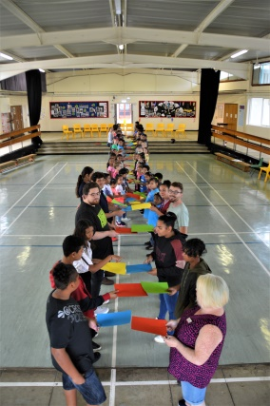

Post 16 Education.
Thursday 16th September 2021 we made history as our first Post-16 cohort logged on and started their A Level studies. What a great moment this was! It was a long time coming and wouldn’t have happened without the collaboration and support of many on the Island. Huge thanks are extended to all who supported this venture particularly the AIG for funding the course fees and to the SURE team for sponsoring the internet package, to both companies and their work forces for the preparations to ensure that our Post-16 room was up and ready for the students. There is no doubt that that the students will find online learning a challenge but they will be offered some tutoring by staff here at school and Miss Francis will keep a watchful eye on them as their mentor. Good Luck guys! May this be that start of your journey onto achieving your dreams, we will be with you every step of the way!
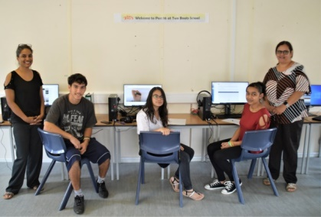
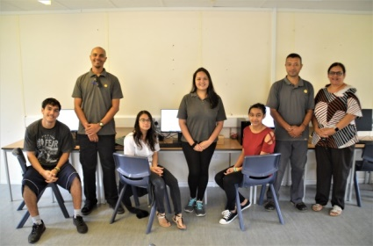
To the parents if you would like to offer your support we are looking for a parent governor for our school governing committee and we are also looking to form a new PTA. So if you are interested in either of these please do get in touch. We look forward to hearing from you.

That’s it for this week.
Mrs. Maggott
A very warm welcome to our new Nursery children.

Starting school is always an exciting time in a 3 year old’s life but it can also be a time of feeling anxious too. On Thursday morning we welcomed 7 new little people into our Early Years setting. They had an amazing time! They explored the setting and were very busy having a go with all of the activities. Mrs Roberts and Mrs Glynis were very proud of them and we look forward to an exciting year ahead.
