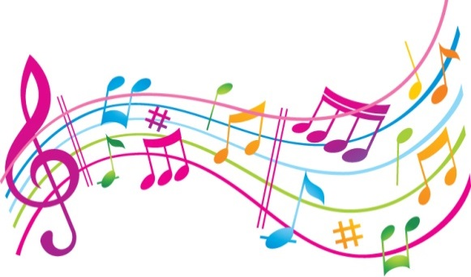
Music
Individual Music lessons will start next week or the following week. Times will depend on other clubs and activities, so it is better not to rush in. Everything will be sorted by week three.
For all instrumental lessons I would ask that parents and pupils commit for at least a full year. If a pupil wishes to stop lessons, I would ask them to give a FULL TERM’S NOTICE. This allows pupils to have a cooling off period. It prevents pupils giving up suddenly for a reason that will pass, such as wanting to attend another club, or not feeling like it on one particular day. Lessons are free but cost time and effort. So, should your child express a wish to learn, make sure they understand they need to give it a minimum of a year.
Violins are provided: guitars need to be bought for your child. If you want to be advised about size – please feel free to ask.
Ryall, who is with us for 1 year is offering tuition in drumming for individuals. Since this is a special opportunity, I would offer these to those who want lessons, but have already shown a gift in that direction during Music lessons. Lessons would be individual.
I want to offer a keyboard skills club to people in years 10 and 11who are serious about learning more about chords and reading music. There are 6 keyboards so that is the maximum number.
Also, during last year 6 violinists left the island, leaving 6-8 places on offer for new learners. These are proper lessons based on the curriculum of the Associated Board of the Royal Schools of Music program. Grade 4 counts as a GCSE, and Grades 7 and 8 as an A level, so can be used in job applications.
Let’s have another great year for Music at Two Boats School.
Ruth Halden.

